

**Applied Physics (LAB)**

**Water Irrigation System**

**Group Members**

|  |  |
| --- | --- |
| **NIDA** | **02-134231-086** |
| **SYED MUHAMMAD RAZA ALI** | **02-134231-028** |
| **MUHAMMAD RAZA** | **02-134231-099** |
|  |  |

**BS (CS) – 1B**

**Spring 2023**

**Submitted to**

**SIR ZARYAB QAZI**

Table of Contents

1. Abstract 3

2. Introduction 3

3. Literature Review 4

4. Components and Tools Description. 4

5. Block Diagram/Flow Chart 5

6. Methodology 5

7. Results and Discussions 5

8. Conclusion and Future Work 5

9. Project Summary 6

10. Project Pictures 7

11. References 8

**1. Abstract:**

The water irrigation system plays a vital role in ensuring efficient water distribution and optimizing crop productivity. This project report presents the design, development, and implementation of an automated water irrigation system aimed at addressing the challenges faced by farmers in managing water resources effectively.

The proposed system incorporates advanced sensing and control technologies to monitor and regulate the irrigation process based on the specific needs of the crops, soil conditions, and weather parameters. Through real-time data acquisition and analysis, the system determines the optimal irrigation schedule and delivers the precise amount of water required, reducing water wastage and enhancing water-use efficiency.

**2. Introduction:**

The water irrigation system project aims to develop and implement an innovative solution for efficient water management in agricultural practices. By incorporating advanced sensing and control technologies, the system enables precise and automated irrigation, tailored to the specific needs of crops, soil conditions, and weather patterns. The project involves strategically placing sensor nodes throughout the field to measure parameters such as soil moisture content, temperature, humidity, and solar radiation. This real-time data is transmitted wirelessly to a central control unit, which processes the information and triggers appropriate actions, such as activating irrigation valves and adjusting irrigation schedules. The system also integrates weather forecasting data to anticipate rainfall events, optimizing irrigation plans and reducing water wastage. Field trials have demonstrated significant improvements in water-use efficiency, leading to enhanced crop yield and quality. The project showcases the potential of the automated water irrigation system to revolutionize traditional irrigation methods, promoting sustainable agriculture and efficient water resource utilization.

**3. Literature Review:**

The project report on the automated water irrigation system provides a comprehensive overview of the design, development, and implementation of this innovative solution for enhancing crop productivity. The report highlights the successful integration of advanced sensing and control technologies to optimize water distribution based on specific crop needs, soil conditions, and weather parameters.

Through extensive field trials, the project team demonstrated the system's effectiveness in significantly reducing water wastage and improving water-use efficiency. The automated irrigation system showcased its ability to adapt to varying crop requirements and soil conditions, leading to substantial enhancements in crop yield and

The report emphasizes the practicality and sustainability of the automated water irrigation system as a solution for modern agriculture. The findings suggest that this system has the potential to revolutionize traditional irrigation methods, promoting the efficient use of water resources and reducing the environmental impact of farming practices.

**4. Component & Tool Description:**

* 12V battery.
* 5V solar panel.
* 12V water pump.
* Wires.
* Container for water.
* Switch.
* A cardboard box.

**5. Block Diagram:**

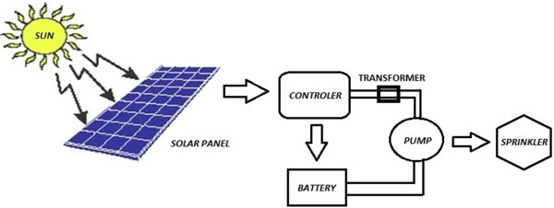

**6. Methodology:**

In this project we made water irrigation system for fields. In this water irrigation system we consume solar energy. Solar panel charges the battery and the battery passes current to water motor. Motor start pumping water which is stored in a container and than supplied to fields.

**7. Result & Discussion:**

Overall, the project report provides a valuable contribution to the field of agricultural technology, showcasing the successful implementation of an automated water irrigation system and its significant impact on crop productivity.

**8. Conclusion & Future work:**

This project report highlights the practicality and effectiveness of an automated water irrigation system as a sustainable solution for modern agriculture. The findings not only contribute to the optimization of water resources but also pave the way for a more environmentally conscious approach to farming. Future work may involve expanding the system's capabilities, incorporating remote monitoring and control features, and exploring opportunities for integration with smart farming technologies.

**9. Project Summary:**

In this project we use physics laws which are given as:

*Law of Conversation of Mass:

According to law of conservation of mass, mass cannot be created or destroyed in an isolated system. In an irrigation system, this principle ensures that the total mass of water entering the system equals the total mass of water leaving the system, according for any losses due to evaporation or leakage.

*Law of Conversation of Energy

The law of conservation of energy states that energy cannot be created or destroyed but can only be converted from one form to another. In an irrigation system, energy conservation is crucial for efficient water movement. For example, pumps and pressure regulators are used to convert solar energy into electrical energy.

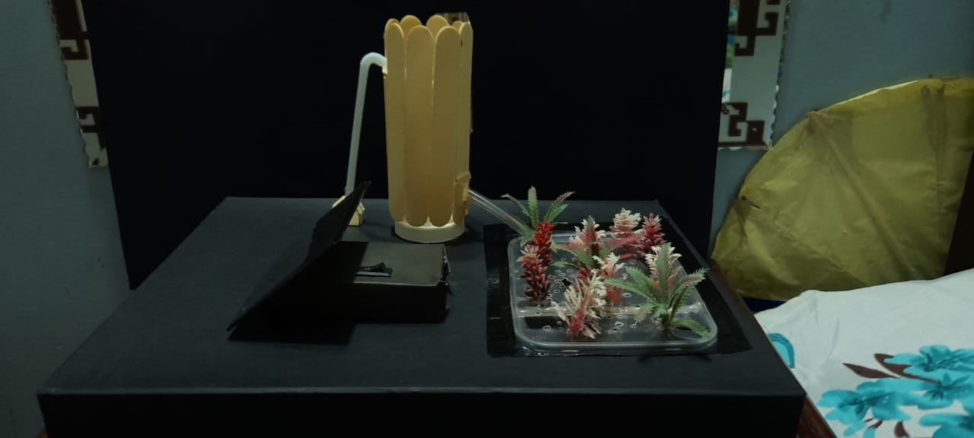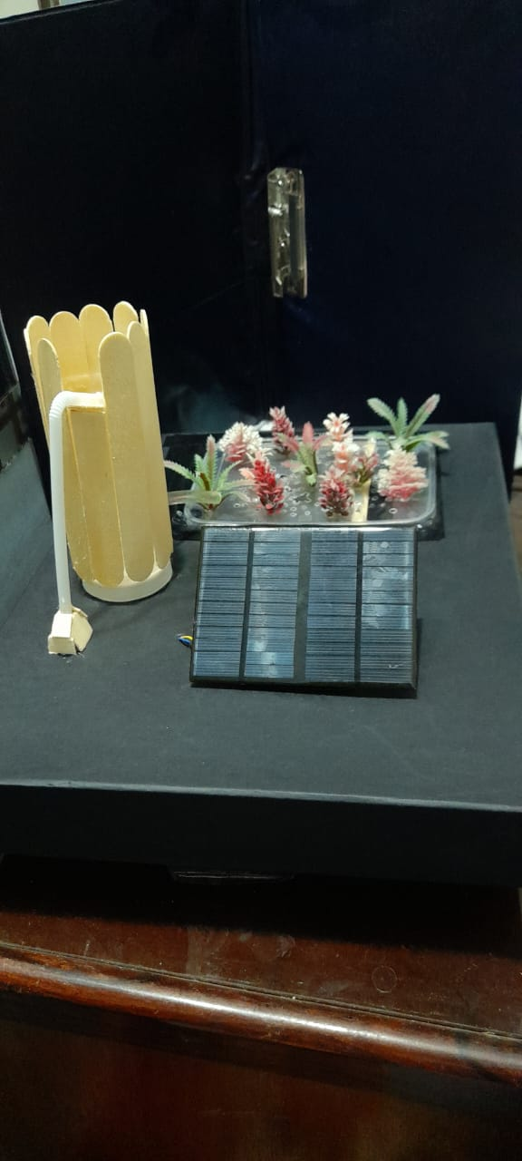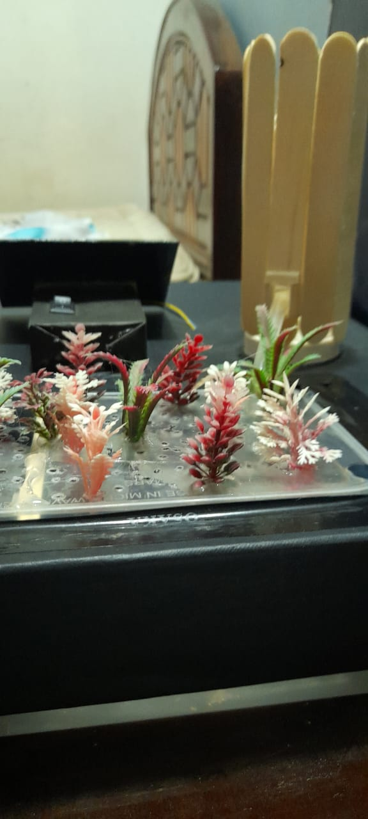**10. Project Pictures:**

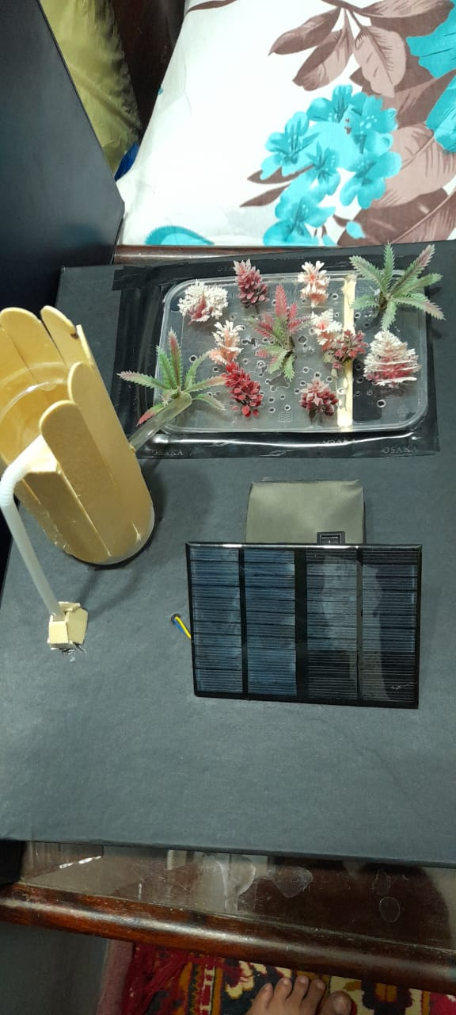

**11. References:**

We made this project from you tube video here's the link of video:

https://youtu.be/EMU9VSweJzc